**I AM …**

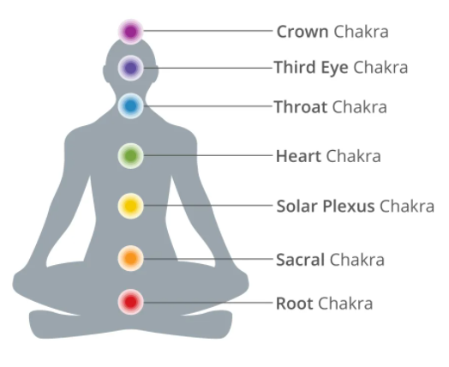

I am the Resurrection and the Life.

I am the Light of the World.

I am the Good Shepherd.

I am the Bread of Life.

I am the Door.

I am the Way, the Truth and the Life.

I am the True Vine.