October 1 – Pause and Review
Beverly McCune

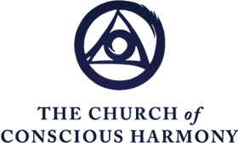

The Ray of Creation

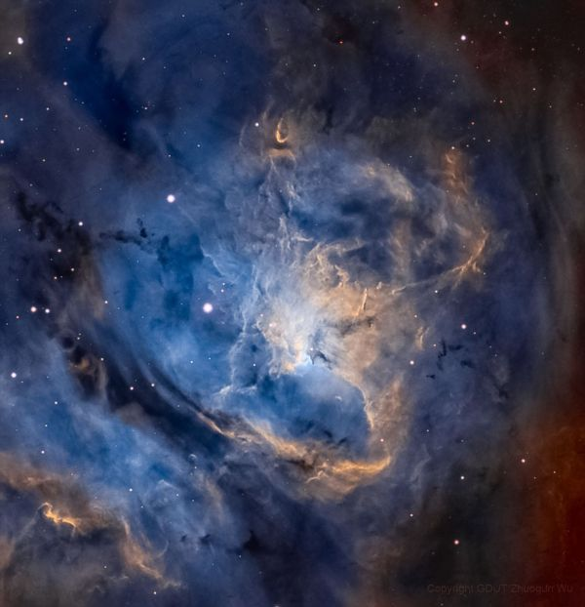

"Creation is evolution and evolution is creation" and the Ray of Creation describes both. It describes great, interconnected spectrums of unmanifest and manifest, energy and matter, the macrocosm and the microcosm, with the relative density of laws affecting every particle and form and level of being.

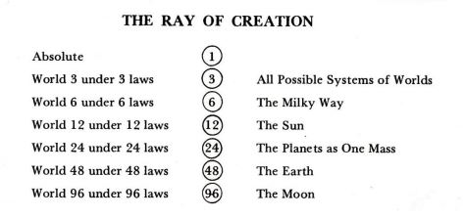

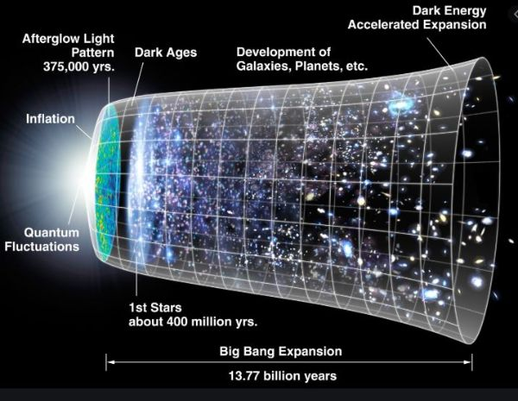

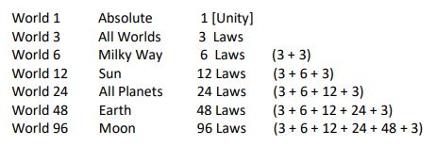

The Law of Three

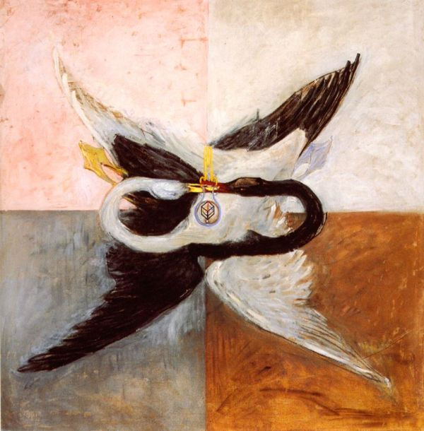

"The Law of Three is the Law of the Three Forces of Creation… Every manifestation in the Universe is a result of the combination of three forces:
Active force or first force or Holy Affirming
Passive force or second force or Holy Denying
Neutralizing force or third force or Holy Reconciling

How can we apply the principles of the Law of Three in our own Work?
- Realize 2nd Force is necessary
- What do I want?
- Calculate 2nd Force
- What is my 3rd Force in this moment?

The Law of Seven

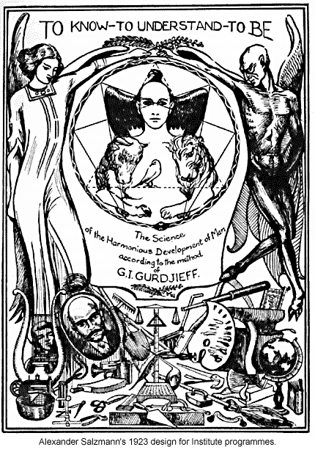

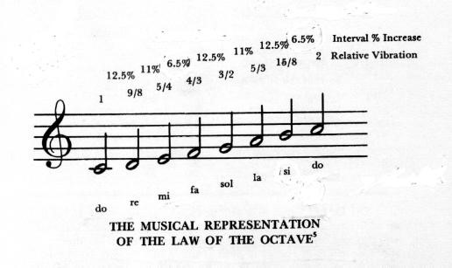

The Ray of Creation and a Descending Octave

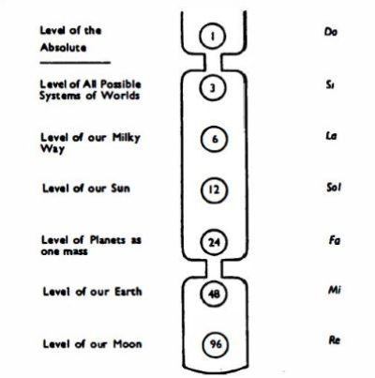

The Work Octave and an Ascending Octave

Do
shock
Si – doing
La – willing
Sol – aim
Fa – understanding
shock
Mi – acknowledging difficulty
Re – knowing, application of Work ideas
Do – hearing, valuation

Christification: The Side Octave

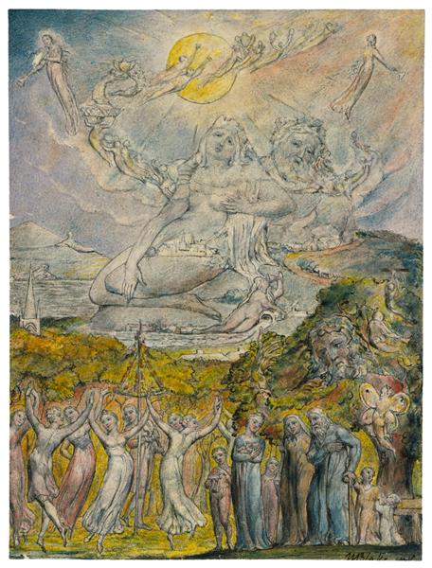

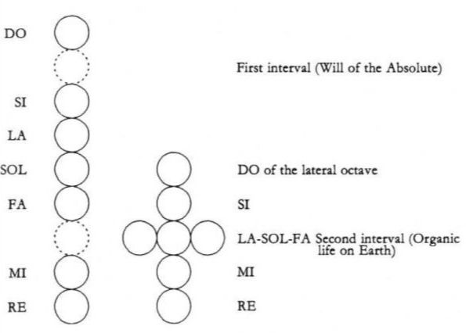

- The Sun created the side octave to serve the Great Ray AND to get something for itself
- Organic life serves as a transmitting film to allow the energies coming down the Ray to pass easily to the earth and moon
- Humans - created as self-developing organisms – have the potential to ascend the side octave to the level of the Sun.

How can the side-octave be applied to oneself?
- We can ask: What message do you have for me? as a means of Self-Remembering – of opening to and listening for the guidance of higher centers
- We can observe what level of food of impressions we are exposed to and consuming and make more conscious choices
- Participation in all three lines of Work, and all five Obligonian Strivings

Time and Eternity
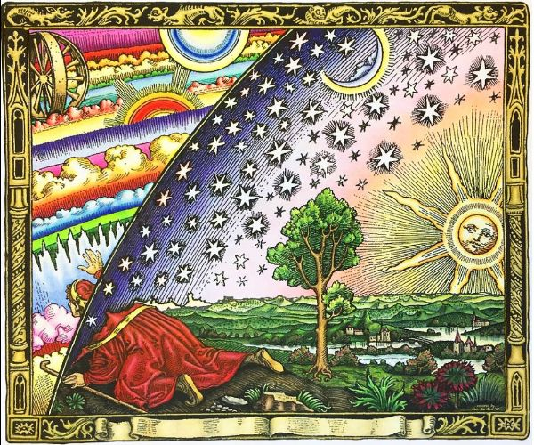

Time is Breath

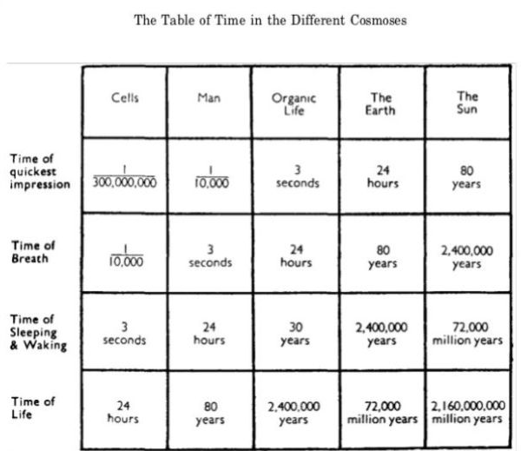

Time and Eternity

- Our bodies experience outer time; our intellectual and emotional centers can experience different rates of time
- “Our experience of ‘time’ is relative to our state”

The Relation of Time to Eternity

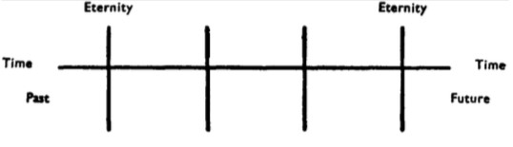

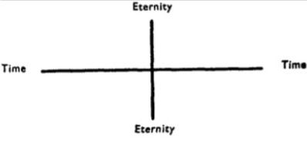

Time Body

- We can change our past and influence our future through Work in the present moment

Scale

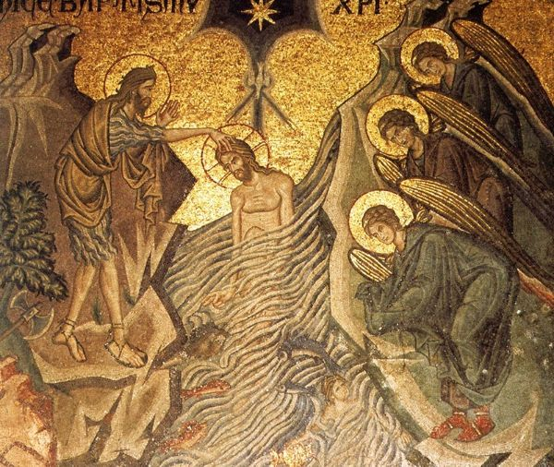

Work Idea: Things are on Different Scales

- Energies are finer and denser in vertical scale
- Scale can be a tool for Self-Remembering
- We can rise from one level of consciousness to another in vertical scale
- “To think in terms of scale is to think in a new way”

The Choice of Influences and Impressions

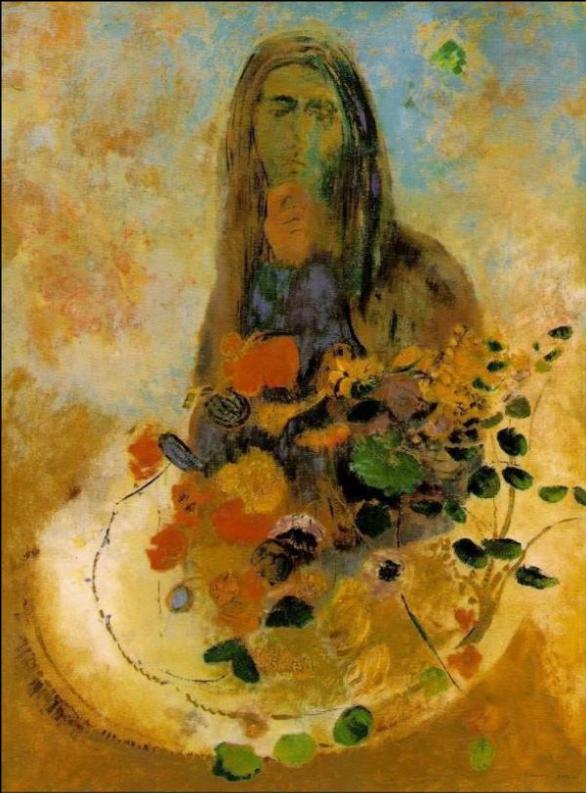

Levels of Influence

- A, B, C influences
- Impressions: exterior and interior
- Inner taste as a way to discern what influences and impressions help or hinder our Real Aim and evolution

Reciprocal Maintenance: The Economy of Sacrifice

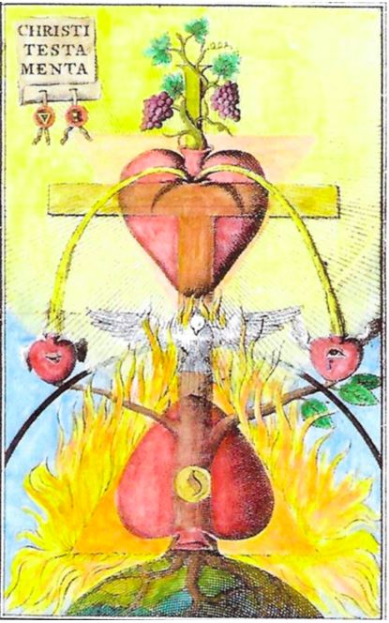

What is Reciprocal Maintenance?

The Diagram of Every Living Thing (Step-Diagram)

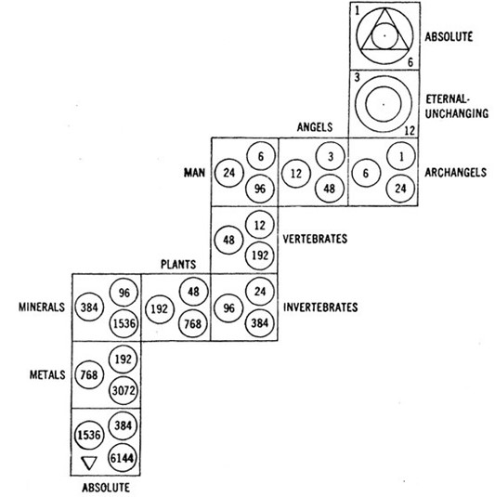

What is our part in reciprocal maintenance?

- Serving involution (the descending Ray) & evolution (ascending the Side Octave)
- Creating “moon” in ourselves
- Serve as living transformers for the transubstantiation of energy

