September 17 – Influences and Impressions
Beverly McCune

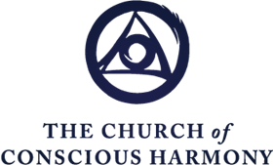

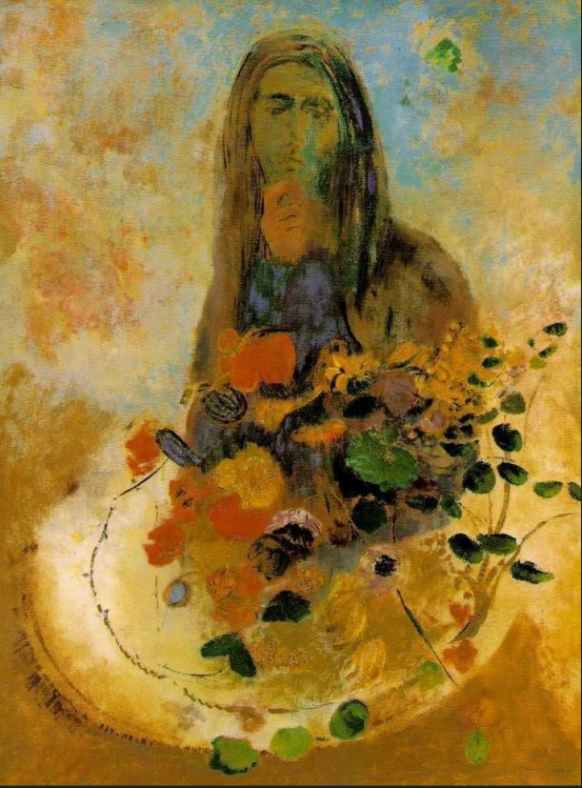

Influences and Impressions

Definition of Influence:
The capacity or power of persons or things to be a compelling force on or produce effects on the actions, behavior, opinions, etc., of others

Levels of Influences
- A influences are generated on the horizontal plane of life.
- A influences cancel each other out through their polarities and create nothing new. They keep humanity hypnotized and asleep.
- B and C influences are vertical, and come to us from a higher level than life.
- C influences come from the Conscious Circle of Humanity, but such finer energies are not able to be directly received by undeveloped humanity.
- Higher Centers conduct C influences.
- B influences originate as C, but are inevitably altered by life into B so as to be understood (Gospels).
- Other examples of B and C influences: the silence of contemplative prayer, Great Nature, the Eucharist, certain art and music, and the transmission from great spiritual teachers in person or in their writings and talks.

Impressions
Definitions:
- The first and immediate effect of an experience or perception upon the mind; sensation.
- The effect produced by an agency or influence.
- A notion, remembrance, belief, etc., often of a vague or indistinct nature.
- A mark, indentation, figure, etc., produced by pressure.

- They are material vibrations that touch our centers and combine with their own vibrations, to enhance, refine and increase their frequency.

- The supreme physical impression that we can give our whole machine is that of Self-remembering.

- The highest impression is the feeling of Real I. This does not come from outside but is an impression from inside.

Choice
- Prior to choice is wish/desire for something: what will we spend our attention on?
- Who or what in us makes a choice?
- Choices are often unconscious
- Conscious choice can involve “effort”: effort without resistance. Observe the impulse to choose something that seems to not serve you, accept it and use a Work idea or question such as “will this bring me closer to God?” or “will this serve my Real Aim?”. If I still go with the original impulse, observe UNCRITICALLY all three centers (“If you can’t help it, will it”). Inner taste will help.
- Over time as we do the Work of Self-Observation, making choices that serve us become easier.

