July 30, 2020 – Review of Humanity
Lauri Raymond

The Transformational Spark

Food of Impressions

Every effort of attention to think in a new way, every three-centered wish for our highest potential, every jump for the rope to catch hold of a Work idea, every fervent prayer for help, every turning of our attention toward impressions of beauty and truth, every willing surrender to God's will – introduces, in its own way, first conscious shock.

Homework – Utilize one or more of the practices listed in the email to apply the transformational spark of first conscious shock to incoming impressions (whether inner or outer).

A deep, full breath: It is very good.

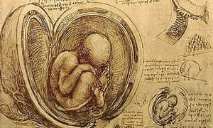

Pause and Review: Humanity

When I see your heavens, the work of your hands,
the moon and stars that you set in place –
What is man that you should be mindful of him?
Woman, that you should care for her?
- Psalm 8:3-4

God looked at everything God had made,
and found it very good.
- Genesis 1:31

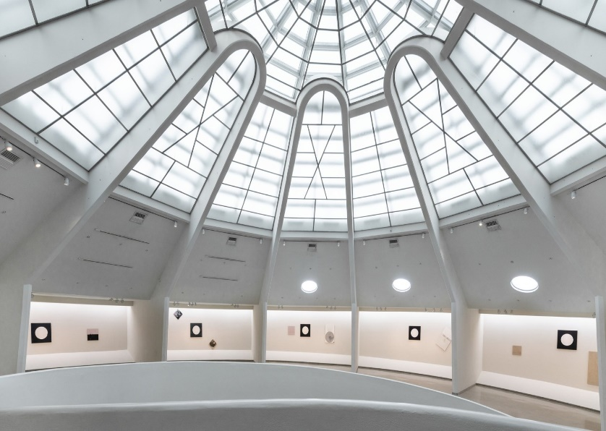

An Unfinished House
One of the most useful Work analogies is the idea that, while there is a divine blueprint, we are created an unfinished house. We are self-developing organisms.

We not created in the perfected image and likeness of God. Why?

"To be created perfect would mean that we had no Work to do on ourselves at all."

In other words, we are given the great gift and possibility of participating as junior partners in our own development.

"[If] you receive this Work into your hands and especially into your hearts, then you will find that the circumstances in which you were born are the very things that give you force if you work."
– Maurice Nicoll, Commentaries, "The Work-Conception of Man as a Self-Developing Organism"

What's in this house?
Many rooms on three ordinary levels:
- Moving Center – body and its concerns of movement, survival, sex & food

- Emotional Center – feelings and concerns of affection/esteem, like/dislike

- Intellectual Center – thoughts, calculations, measurings, and comparisons
This house – largely unexplored – is overflowing with very many manifestations: some familiar, others unimagined and undiscovered.

- Useless suffering – recurrence, multiplicity, small wills, negative emotions, associations, identification

- Undiscovered treasures – Real Wish, Higher Centers, Real Conscience and Consciousness, Real I

The Work shines the light of Work ideas into this house of self – into its shadows and neglected areas, the heretofore unaccepted areas.
With a sense of discovery and delight, we practice non-critical self-observation, non-identification and Self-remembering.

"Once these qualities you object to are seen in yourself …
They are not in your dark side any more
and don't have so much power over you.
You gain power over them by naming them.
Then there is nothing dark or hidden.
There is Light everywhere.
When you have known yourself on this level
you will know yourself on another level."

- Beryl Pogson, Centenary Fragments
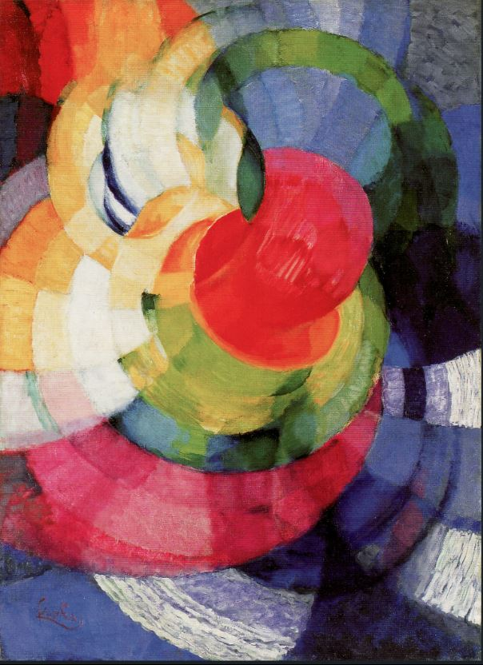

Levels of Being

Though humanity is one at the ground of our being, most individuals live at different levels of being.

What is our primary center?

Many of us are mainly "one-centered." We reside and perceive everything through one center:

- Instinct-moving center – number 1 human
- Emotional center – number 2 human
- Intellectual center – number 3 human

First, we are called to be number 4 human – Balanced Human.

What is Balanced Human?

- Balanced so each center works in its own proper way
- Balanced between inner and outer parts of centers

Along the way, we may begin to manifest the gifts and fruits of numbers 5 – 6 – 7 humans, those who are conscious and can understand themselves, one another and Reality as it is. Such ones exist on a wholly different plane, even amidst ordinary life.

"To achieve this state, the first essential step is self-observation."
- From Beryl Pogson, The Work Life

Personality – Essence – Real I

Real I is inmost Self – innate, whole, permanent, a unity of being, rooted in God, in Ultimate Reality, spacious, free of content. Real I is created in the image and likeness of God.

Fortunately, as self-developing organisms, we have within us – in every moment, if we only knew it:
- Many levels of consciousness

- Essence, a divine center capable of development

- Personality – an interface between essence and life, and it serves as an organ of digestion for the transformation of impressions into the energy needed for us to awaken and arise through levels of consciousness

- Access to Higher Centers

- Real I

Real I is inmost Self – innate, whole, permanent, a unity of being, rooted in God, in Ultimate Reality, spacious, free of content. Real I is created in the image and likeness of God.

Real I is what it means to express a divine-human destiny, a full human life as it was created to be in our own particularity.

Aim, Wish and Will

Thy Will Be Done
"This personal work of self-observation is for all one's life. Out of it comes the dawning of Real Aim, which in its greatest formulation is the desire to awaken."
- Maurice Nicoll, Commentaries, "Commentary on Aim"

The primary wish in the Work – Real Wish – is:
- To awaken
- To increase consciousness
- To be transformed.

Wish
- Is connected to and enlivens the will
- Engages all three centers of our being
- A full body YES to an aim

Wish is the most powerful thing in the world because the Universe is response to request.

Ask and you shall receive …

… although not necessarily in the way you think it should look.

Ultimately, every aim, wish and manifestation of will is in service to living out of Thy Will Be Done as a form of Self-remembering.

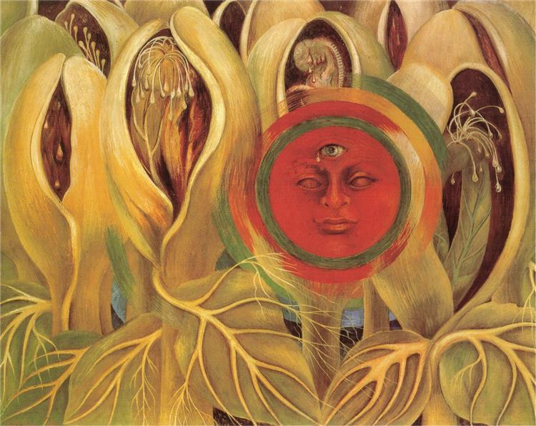

Conscious Labor and Intentional Suffering

As will to God becomes all and everything, the fruits of a surrendered, receptive will include conscious labor and intentional suffering.

Our lives are required for something …

- Two distinct states and actions that often work synergistically.

- Manifest as self-love – concern with me and mine – diminishes.

- They are the fruits and graces of our prayer and Work.

- They involve community. We cannot do this in isolation. We need each other.

- We participate in them without regard to results. With non-identification.

"If you come into this Work only for what you can get for yourself, you will be disappointed. But something else can enter, the realization that it does not matter what one can get for oneself as long as one can do something that is necessary. This is a real step in our transformation."
- J. G. Bennett, Talks on Beelzebub’s Tales

Homework
Read through today's email a few times this week.

Reflect and listen for any topic that comes to meet you, perhaps returning to the in-depth exploration of the original email.

Allow it to integrate into your awareness and being.

Rest. Give gratitude for this precious life.

I ask to be the servant of the Lord,
a vehicle of divine love,
a channel of God's will.
I ask for direction and divine assistance
and surrender all personal will though devotion.
I dedicate my life to the service of God.
I choose love and peace above all other options.
I commit to the goal of unconditional love and compassion
for all life in all its expression
and surrender all judgment to God.
Amen.

