July 23, 2020 – Food of Impressions
Lauri Raymond

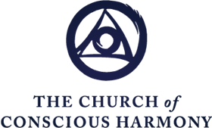

Our lives are required for something.

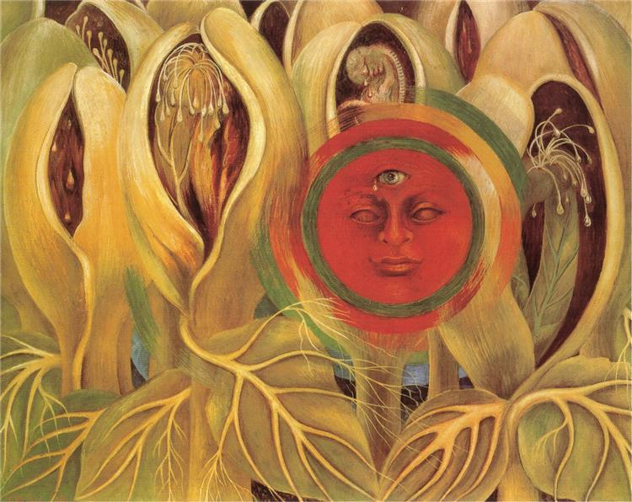

Conscious Labor & Intentional Suffering

- Two distinct states and actions that often work synergistically.
- Manifest as self-love – concern with me and mine – diminishes.
- They are the fruits and graces of our prayer and Work.
- They involve community. We cannot do this in isolation. We need each other.
- We participate in them without regard to results. With non-identification.

Homework
- Choose one area of your life to practice conscious labor or intentional suffering. Non-critically observe patterns of useless suffering. Non-identify and Self-remember. The Welcoming Prayer is an excellent practice for a three-centered, embodied way of digesting both useless and intentional suffering.
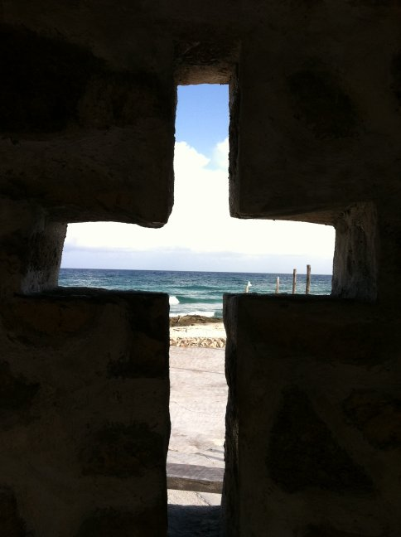

Food of Impressions

- Our surrendered will to God yields capacity to participate in conscious labor & intentional suffering.

- Conscious labor & intentional suffering, in turn, inspire continued ora et labora, prayer and Work.

- Perhaps the greatest energetic treasure in the field of our Work comes from the understanding of how to digest the food of impressions.

What is the food of impressions?

- Along with the other two foods – food that we eat and air that we breathe – impressions also provide energy for life.

- What we see, read, touch, taste, hear, smell outwardly.

- What we think, feel and sense bodily inwardly.

- Impressions from Real I and Higher Centers are always transmitting, but due to interference in our state of being, we are unable to hear and respond to them.

- We're born with the capacity to digest the first two foods – in other words, our bodies transform them into substances of higher energetic levels to nourish and sustain us. Of course we know well that the quality of the food we eat and the air we breathe can affect our well-being. What we may not be aware of, is that the preparation and presentation of our food and our state of being while we prepare, present and eat is important. To receive our food with gratitude and presence enhances its digestion and ability to nourish us and actually contribute to high energetic levels affecting the transformation of our being – or not.

- Yet as we are, the food of impressions doesn't transform into something higher. As self-developing organisms, we must develop the means of digesting the food of impressions.

What does this mean?

- As we are – asleep much of the time – we don't really take in very many impressions. We don't have eyes to see or ears to hear. Take our surroundings: Do we really see the trees and houses on our street? Do we really taste and smell our food?

- As we are, the way we take in these impressions – our perception – is mechanical, limited, and just plain wrong.

- We confuse our perceptions of life – habits of mind, feeling and body, the Work calls associations – with life itself.

"We take our typical reactions to impressions as life. We take our reactions to a person as him or her … Life is our impressions of it and these can be transformed." – Maurice Nicoll

How? First Conscious Shock
First conscious shock is:

- The conscious effort to receive impressions in a new way.

- The practice of Self-remembering that leads to the state of Self-remembering.

- The energetic spark that ignites the alchemical transformation of the way we take life and, hence, of our very state of being.
"Just to live a moral, well-ordered life is not enough. We need consciously to fulfill the obligation to produce the special energies that are required of us …" - J.G. Bennett, The Sevenfold Work

What is meant by special energies?

- Every substance, every thought, every impression that we see, hear or read has an energetic level.

- In the Work, these energetic levels are referred to as Hydrogens.

- The higher the energetic level, the lower the number.

- In our waking sleep, impressions enter and trigger long-standing associations. They are not transformed into something higher and so do not really feed us.
- "Further Commentary on Self-Remembering, Mar. 6, 1948, Vol. 3, p. 1137-9
- With the effort of attention of first conscious shock, introduced at the point of incoming impressions, they are fruitfully digested – transformed. Higher energies are created that serve transformation into higher levels of being.
First Conscious Shock = The Ferment, the Catalyst, the Energetic Spark that Transforms Impressions

Note on diagram: The numbers are from the food diagram, but this illustrates the introduction of an influence with a higher energetic level (digestive juices - 192) to a food unusable in its current state (uncooked potato - level 768), transforming it into a substance of intermediate level (nutrients which can be used by the body - 384) The same idea is how impressions are transformed.

The Point

When we introduce something of a higher energetic level at the point of incoming impressions, it is transformed – digested – into the energy needed for transformation into higher levels of being possible for all humankind.

"In the ascending octave toward consciousness, remembering oneself is the shock that is necessary to pass the interval between mi and fa – the first conscious shock. It brings a force that can only come from the wish, the will. We must make the will grow degree by degree, step by step." – Jeanne de Salzmann, The Reality of Being

Bottom Line – To Confirm for Ourselves – The Crystal View

Think of a faceted crystal as another way of seeing dog ball theology*. When we cleanse the lenses – facets – we see through, we see God's view of the world. Good and Very Good.

As with a movie projector, if the lens is dirty, we are projecting – creating – a world that is dull and dark. If the lens is cleaned, the movie is transformed into the vision of its creator.

Now creation shines forth with vividness and color. We not only see God's view of the world, we live in God's world. We are A New Creation and the world is A New Creation.

What's more, the aggregate of all our views of the world, creates the world. So our prayer and our Work raise the level of being of all. God's life, love, beauty, truth and justice shine through us.

*An analogy introduced by Tim Cook. A dog ball with little protrusions is a good illustration of our individuality and Oneness. We seem separate, but in the ground of our being are connected with all others, creation and God.

If the doors of perception were cleansed
everything would appear to man as it is,
Infinite.
- William Blake

Every effort of attention to think in a new way, every three-centered wish for our highest potential, every jump for the rope to catch hold of a Work idea, every fervent prayer for help, every turning of our attention toward impressions of beauty and truth, every willing surrender to God's will – introduces, in its own way, first conscious shock.

Homework

Utilize one or more of the practices listed in the email to apply the transformational spark of first conscious shock to incoming impressions (whether inner or outer).

"How I live in this moment, therefore, makes a difference to my eternal existence, to the final definition of my life, and what my life means for the world, since the final decision of my life – in this moment – is my irreversible contribution to the world." - Ilia Delio, Omega Center News, July 13, 2020

Amen

