July 16, 2020 – Conscious Labor & Intentional Suffering
Lauri Raymond

Conscious Labor and Intentional Suffering

Sharing as a Fool for the Work

To share is courageous; it is a gift to you and others. It opens one to the possibility of being "a fool for the Work." It affirms observations in being and imprints a cellular knowing. It is also an art-form. A Work-form, so to speak. That is, to share in the Work is to put oneself under the authority of the Work: non-critically self-observing, non-identifying, and Self-remembering in all three centers while sharing. Brief. To the point. Without specific references to others. Without story.

"The Fool [seems] to represent (at least in part) the transcendental consciousness of which, at the beginning of our journey, we are more or less oblivious, but which, by the grace of God, is realized or recognized during the course of our pilgrimage.

"Ouspensky: [The Fool is an] ordinary man. A separate man. The end of a ray not knowing its relation to the center.

"The Fool carries with him the symbols of his true identity, although he has long since forgotten what they mean. Nevertheless they belong to him, even though he does not know their use. [They] have not lost their power, they retain it in themselves." - Teenytinytarot.com

This suggests that the hidden potentialities we are born with – Higher Centers, Real I, Real Will and Real Conscience – are with us and can help us if we Work.

Suggestions for sharing as a fool for the Work:

- Pray – Before class and when you raise your hand, feel feet on the floor and pray for the highest good for your participation. Pray for others as they share. Pray for Abbess and Work leaders.

Side Note: Also pray for those in the sanctuary holding space for us at Sunday services: Pamela for Lectio, Peter, Mary Anne, Don, Deborah, Billie, Sue and Jeff in the main service. When we are present in prayer, it connects us energetically and evolves us as a community.

- Courage – Share without regard to outcome. Non-identify with I's that say: You're not ready. You'll get it wrong. You don't know what you're talking about. You're too new. Our sharing serves our own and others' transformation in ways we cannot know.

- Non-critically self-observe, non-identify, and Self-remember in all three centers while sharing – and after!

Also do this while others share.

- Brief. To the point. Without story. Without identifying references to others.

We wish to be brief out of consideration for others who might wish to share. We wish to be direct and without story to head off insincere I's that might "get rolling" and justify or solicit approval and sympathy. We wish to not use identifying references to others for privacy and to keep the sharing "on our own bones." What did I learn? What did I see?

- Sharing in this way is conscious labor & intentional suffering.

Conscious Labor and Intentional Suffering

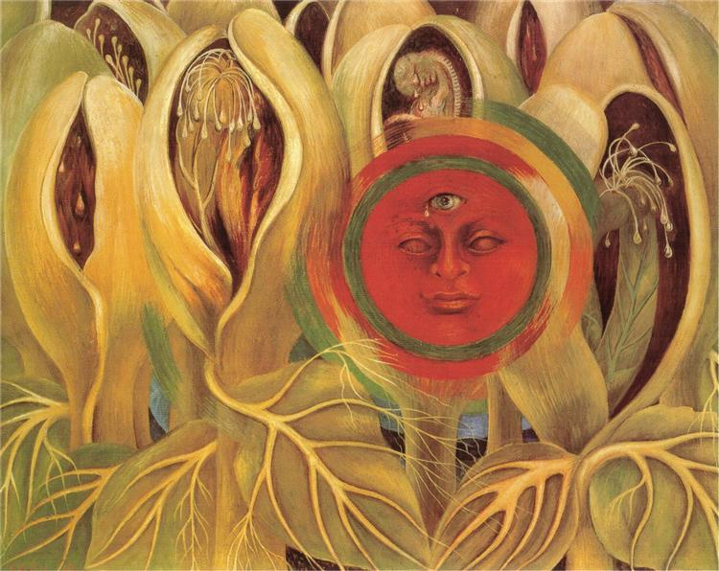

"Our lives are required for something." – J.G. Bennett

Conscious labor and intentional suffering:

- The fruits of a surrendered, flowing, receptive will

- Two distinct states and actions that manifest as self-love diminishes.

How interesting that conscious labor and intentional suffering are described as fruits, states and actions that manifest. As we do pray and Work, these are given to us and will, in turn, engender more Work.

- We need each other. We need the whole human race.

"We not only need one another, but we have an underlying connection by this very fact that the whole of the human race is needed for a certain purpose. If it fulfills this purpose, this human race of ours has the possibility of moving to a very different level of fulfillment, where a new significance can enter human life …" J.G. Bennett

- Though they are fruits of our prayer and Work, conscious labor and intentional suffering always involve payment and sacrifice.

- Through our conscious willingness to make these payments and sacrifices in service to conscious labor and intentional suffering, special energies are produced. These energies are needed for our transformation, but more importantly, for the evolution of all. We'll be talking more about this next week in our class on Transforming Impressions.

- Closely related to the three lines of the Work and the fourth and fifth obligolnian strivings.

- Involve expansion of conscience and consciousness. These states give us new perceptions, new understanding of ourselves and others.

What is conscious labor?

Make present sacrifices – restraints upon our desires and impulses in the present – in service to the future.

- Beyond normal duties and obligations and ordinary service to others. Though even during these, we can Work. What is my motivation? How am I doing this? and Why am I doing this?

- Without regard to the fruits of action, reward, praise, recognition. "Let's go to it."

The sower sows the seed in hope but unconcerned with who will reap the harvest, because the future is the realm of creation; it is open to be created while the present is closing up, perishing, coming to an end.

Bennett quoting Gurdjieff

Indifferent to results, you are willing to work with the most inadequate means. You do not care to be much gifted and well equipped. Nor do you ask for recognition and assistance. You just do what needs to be done, leaving success and failure to the Unknown.

Nisargadatta Maharaj, I Am That

What is intentional suffering?

- Unnecessary or useless suffering – all identification and suffering arising from self-importance and concerns with me and mine.

- Unavoidable suffering – from events beyond our control: war, disaster, disease, death, pandemic.

- Voluntary suffering – to accomplish a life aim.

- Intentional suffering – we willingly work to serve an impersonal or altruistic vision, one that is directed more towards service to others or to the Work, and not for any personal gain.

Note: Through prayer and Work in conjunction with any of these types of suffering, our Work yields intentional suffering.

In intentional suffering:

- We willingly engage in conscious labors.

- Always involves pain and suffering, inconvenience, difficulty.

- Without intentional suffering, conscious labors will become dry and empty. Through intentional suffering, the meaning of conscious labor changes. We see the good of it for ourselves and others, so we will it; we move toward it.

- Is concerned with the purification of emotional center – the sacrificing of our negative emotions.

When we participate in second and third-line work, we get to self-observe, non-identify and Self-Remember around:

I'm not good enough. I don't know enough, I don't know what I'm doing, I don't have enough time or support. It's too hard.

- Is concerned with the body – the issues in the tissues. Willingness to move toward the discomfort with acceptance.

- Welcoming Prayer

Homework:

Choose one area of your life to practice conscious labor or intentional suffering. Non-critically observe patterns of useless suffering. Non-identify and Self-remember. The Welcoming Prayer is an excellent practice for a three-centered, embodied way of digesting both useless and intentional suffering.

The essence of saintliness is total acceptance of the present moment, harmony with things as they happen. A saint does not want things to be different from what they are; he knows that, considering all factors, they are unavoidable. The saint is friendly with the inevitable and, therefore, does not suffer. Pain he may know, but it does not shatter him. If he can, he does what is needful to restore the lost balance – or he lets things take their course.
Nisargadatta Maharaj, I Am That

The Welcoming Prayer

A method of consenting to God’s presence and action in our physical and emotional reactions to events and situations in daily life. The purpose of the Welcoming Prayer is to deepen our relationship with God through consenting in the ordinary activities of our day — "consent-on-the-go."

- Feel and sink into what you are experiencing this moment in your body.

- "Welcome" what you are experiencing this moment in your body as an opportunity to consent to the Divine Indwelling.

- Let go by saying "I let go of my desire for security, affection, control and embrace this moment as it is."

