April 16, 2020 – Self-observation
Donald Genung

Self-Observation:

- Self-observation is an act of attention directed inwards – to what is going on in you.
- The attention must be active – that is, directed.
- Requires directed attention, not passive attention.
- The attention comes from the observation side, whereas the thoughts and emotions belong to the observed side in yourself. This is dividing yourself into two. There is a saying in the Work: "A man is first one, then two, and then one." The observing side, or Observing I,
stands interior to, or above, the observed side, but its power of independent consciousness varies, because it may be submerged at any moment.
- All this is quite different from merely knowing one is negative. Passive knowing can be said to be mechanical in contrast to self-observation, which is a conscious act and cannot become mechanical. Mechanical self-observation has nothing to do with Work self-observation.
- Self-observation brings about a complete change of the feeling of oneself and begins to dissolve Imaginary I. At the same time, while the process is taking place, we begin to feel influences reaching us from another source of meaning. These influences could not reach us before because there was this thick darkness intervening.
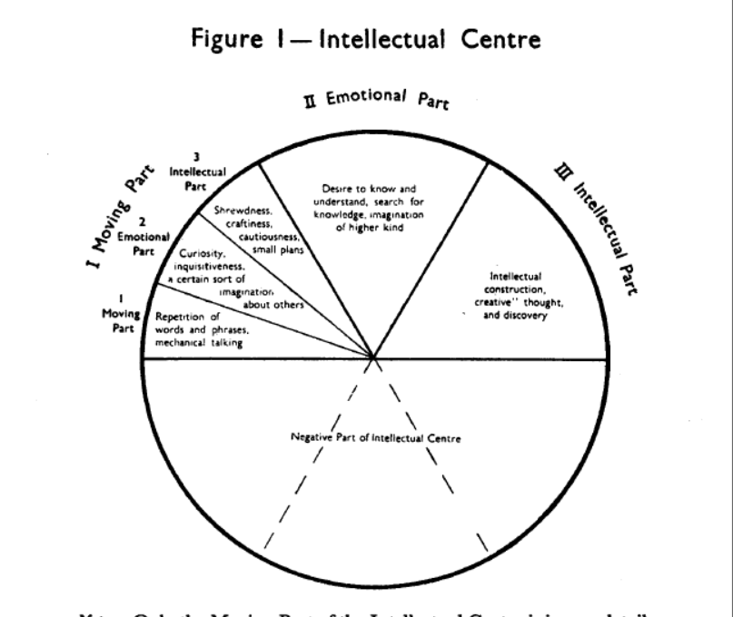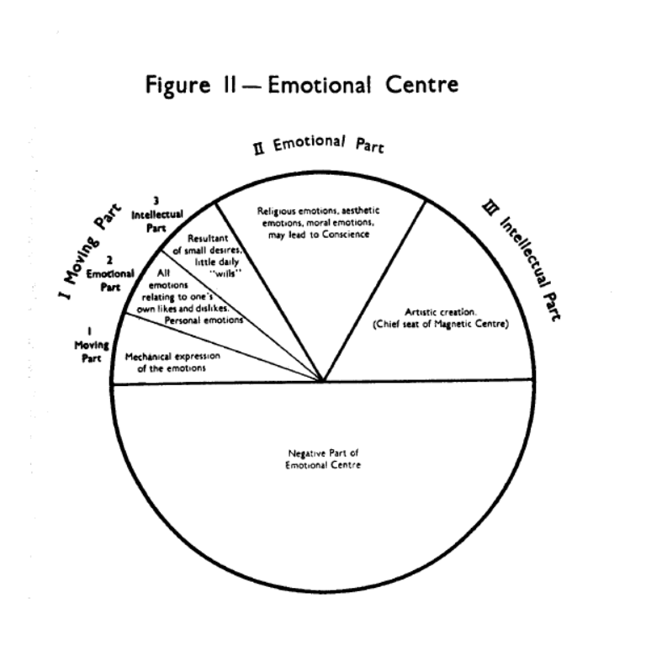

"We now come to attention. Attention puts us into better or more conscious parts of centres. Attention is of three kinds:

(1) zero-attention, which characterizes mechanical divisions of centres;
(2) attention that does not require effort, but is attracted and needs only the keeping out of irrelevant things;
(3) attention that must be directed by effort and will.

As was said, the first kind of attention, zero-attention, accompanies the work of mechanical divisions of centres; the second kind puts us into the emotional divisions of centres, and the third kind into the intellectual divisions. Let us take briefly the Intellectual Centre again as an example, as we shall have to return to this subject next time. The emotional part of the whole Intellectual Centre consists chiefly of the desire to know, the desire to understand, to seek knowledge, to discover, to increase one's understanding, to grasp and find out, to have the satisfaction of knowing, the desire for truth, the pleasure of learning, of reaching out; and, in- versely, the pain of not knowing, the dissatisfaction of being ignorant, uninformed, and so on. The work of the emotional part requires full attention, but in this part of the centre attention does not require any effort. It is attracted and kept by the interest of the subject itself. The intellectual part of the whole Intellectual Centre includes a capacity for creation, construction, invention, finding methods, seeing connections, and bringing together apparently isolated things into an order or unity or formulation so that we see the truth of something hitherto obscure. This part cannot work without directed attention. The attention in this part is not attracted but must be controlled and kept by effort and will; we usually avoid doing the work belonging to this part of the centre, which is thus often unused."
- Maurice Nicoll, Commentaries, "Some Notes on Wrong Work of Centres," Oct. 18, 1941, p. 70

Self-Observation: Components

Self-observation without definite knowledge of what to observe will lead nowhere in the Work.
- Observe the thought train in that moment
- Observe the emotion connected with the thoughts
- Observe the experience the thoughts & emotions are having on the body
- Give the observation a name
- Observe if there is a "critic" giving commentary on what is observed.

Homework:
Remember you come here
having already understood the
necessity of struggling with
yourself – only with yourself.
Therefore, thank everyone who
gives you the opportunity.
- Aphorism inscribed in a special script above the walls of the Study House at Gurdjieff's Institute for the Harmonious Development of Man, Château du Prieuré, near Fontainebleau, France
- When evoked, observe sources of blame, or the dislike of another. Observe in three centers: what are my thoughts, feelings, sensations around this thing/event/person? Consider writing them down, referring to oneself in the third person; that is, "X is thinking this, feeling this, sensing this." Referring to oneself in the third person can bring separation and facilitate self-observation and non-identification. If you already do this often, consider letting go of the practice for now and focus on digestion of the impression in a new way, through practicing first conscious shock.

