March 26, 2020 – Personality
Pamela Begeman

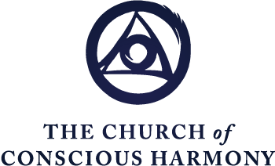

"Guideline 28: The goal of genuine spiritual practice is not the rejection of the good things of the body, mind, or spirit, but the right use of them. No aspect of human nature or period of human life is to be rejected but integrated into each successive level of unfolding self-consciousness. In this way, the partial goodness proper to each stage of human development is preserved and only its limitations are left behind. The way to become divine is thus to become fully human."
- Thomas Keating, "Guidelines for Christian Life, Growth and Transformation," Open Mind, Open Heart

Key points:
- personality is key to becoming fully human, fully who I am and was meant to be (Not an overcoming or self-improvement)
- personality is a key aspect of self as an organ of digestion; it plays an important role in the practice of Understanding (knowledge + being).
- there are many different teachings and perspectives on essence and personality, which indicate they are to be held lightly as models.
- the key to development is Self-remembering: SR feeds understanding, understanding feeds acceptance, acceptance feeds unity and union – the level of consciously chosen love.
+

"Essence is invisible and what is invisible is the cause of the manifest. Essence causes personality. It attracts to itself a personality to do its work in the world and a false personality that has to be overcome [integrated]. (… before birth essence, the part of one's being that one has made one's own, through efforts in previous lives, chooses the circumstances of its next life, including the weaknesses of personality. This notion depends on the fact that active force needs a resistance to work on.).

"[As] the organ of digestion of experience, it is only after much persistent work in personality that experience becomes part of one's understanding; that is, is absorbed in essence.

"It is interesting to think, Mrs. Pogson continued, 'in relation to other people: what is that person going to grow into? … [related to Work idea of external considering]

"The chief way of nourishing essence is by Self-remembering; and also through love of truth and beauty. When something you know about becomes real, it passes into understanding and becomes part of you."
- Beryl Pogson, Brighton Work Talks

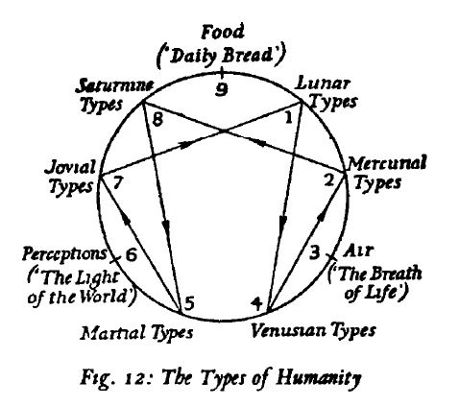

"We may say that [the life of Man] belongs to the Sun, his type or essence to the planets."
- Collin, Theory of Celestial Influence, p. 139

"Each type of essence must be fed in its own way. For the different physical types … are exactly types of essence. What is true food for [one type of essence, saturine], is useless for [another type – martial] and vice versa … Thus each man must being to feel for himself what feeds his essence, what makes him more himself." – p. 256
…
"The first commandment on the way of development is for man to free himself from pretense and imitation, discover how he reacts, discover the nature of this type, and try to live accordingly. He must learn to be himself." -- p.271

"All types are equal, all are necessary, and all enjoy the same opportunity – of movement or stagnation. What is important is not to be of this type rather than that, but to be sound of one's type, recognizant of others and uncrystallized in any." – p. 272

"The next stage of development, which is rarely reached without special aim and preparation, is that of the man who has fully understood that there exists a scheme of types, which are equally necessary and valuable; who has discovered his own type and that towards which he is moving; and who makes conscious efforts to abandon one and achieve the other." – p. 273 [We must accept others as they are.]

"The movement of 142857 is the path toward consciousness, toward all that unites, reconciles and gives understanding of the parts to the whole." – p. 275
- Rodney Collin, Theory of Celestial Influence

+

Characteristics of an exaggerated or disconnected personality:
- based on self-love (Rebecca Nottingham's example of the baker); pride and vanity energize its manifestation
- what is resisted or rejected because of lack of understanding FROM EMAIL: "We can gain further understanding of the nature of personality, when we realize that this light which he reflects is exactly what he does not absorb. What is most obvious about a man is what he rejects and the particular manner in which he rejects it. He is recognized by what he does not yet understand, by that which separates him from the rest."
- the belief and identification with imaginary I, a single-unchanging I

Bernadette Roberts never mentioned personality. For her, it was either about degrees of self and Christ.

The bottom line:
- It's a path of INTEGRATION, WHOLENESS, AUTHENTICITY, TRANSFORMATION
- There is nothing to denigrate and nothing to protect and nothing to glorify. Personality is simply a necessary function of being human.

Advice from the email:

"What is the key to the process? It is to be sincere, to be honest, to be truthful. To be sincere means to find oneself, one's own way, one's own fate, without pretension, without imitation and without fear. To be honest means to pay one's debts to the extent that one can, in order to be able to be free to offer oneself to higher service without other obligation; to realize that everything that is good has its price that has to be paid by someone. To be truthful means little by little to abandon the subjective point of view based on likes and dislikes, and consider everything on the basis of objective laws, on divine truth. That is the preparation."
- Rodney Collin, The Theory of Conscious Harmony

