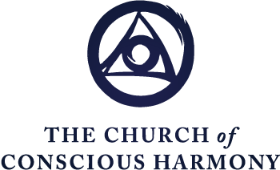

The Spiritual Journey
Formation in the Contemplative Christian Life
“The Archaeological Dig and the Spiral Staircase”
Excerpted from
Centering Prayer: A Training Course for
Opening to the Presence of God
(Sounds True)

Fr. Thomas Keating

The Psychological Experience of Centering Prayer diagram is just a horizontal diagram. To get a clearer concept of it, let’s look at the same process but from a vertical perspective. This is the overall image [pointing to the shaded part of the bottom illustration]. And this is the area that is enlarged, that is translated up here for the sake of clarity. This is an analogy of the tell and the archeological dig with the spiritual journey.
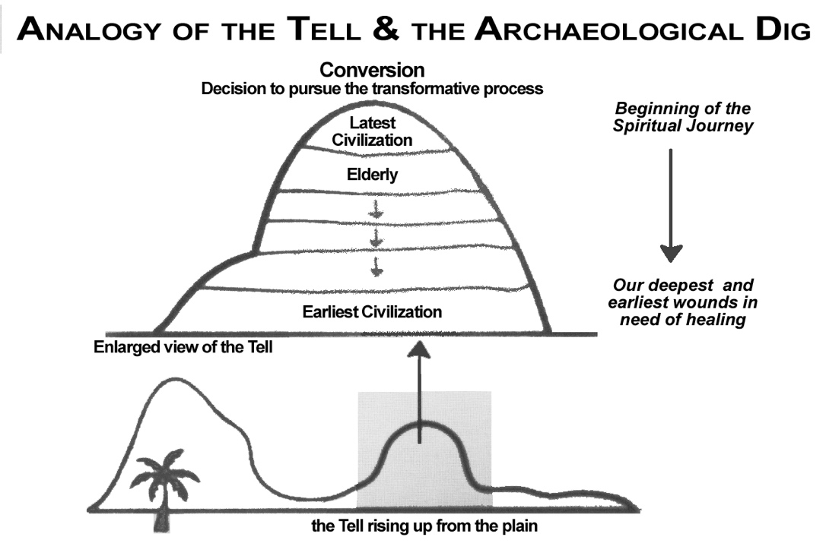
A tell is a hill on a landscape that consists of the remains of city states and civilizations, one built on top of the other. For some reason in those days when you burned down a town you rebuilt your own on top. From an archeological point of view, it is a treasure because in one place they can dig down through many civilizations all the way down to the Stone Age.
The process of course is to clear off the top first, shovel off the junk and the chards that are broken and things that are of no use. Then come back a year later and work at a deeper level.
The analogy is that the Holy Spirit seems to have a certain method to its madness. Although it doesn’t feel bound to follow a particular structure, it adjusts to each person. It starts out our conversion when we decide to pursue the transformative process, by clearing off the obvious conscious junk that is obvious to us as hindering our process and it adds those aspects of a discipline or a meditative process [Centering Prayer] that will help this process to go on.
Wherever you start, let’s say you start in old age, because you can start at any time, it is never too late for this process. The Holy Spirit investigates or brings to our attention what needs to be improved at that point. It then continues the process with a little rest or enjoyment of the new privileges of each state of life, or the new freedom. It works down through adulthood, early adulthood, adolescence, childhood and infancy until each part of our life has been healed or investigated. At each level the group of archaeologists will throw out the junk and send the good stuff, the beautiful artworks and mosaics to the British Museum or some other similar place.
All that is good, even though it was mixed up with a lot of junk at each level of our historical life, is recovered. It may be that the Spirit then invites us to recapitulate at least in our spiritual insight the whole of our life and gives us back some of the things that we weren’t able to pursue, that were good but that we hesitated to do because of the situation we were in at the time. The bottom line is that everything that was good in your life begins to bloom or flourish.
The interesting point I would like to leave with you with is that the closer you come to the original source of the trauma which was in infancy or perhaps even experiences in the womb, the worse you think you are becoming. This is not a success story on the spiritual journey. This is not a climb so to speak, but rather a gradual acceptance and comfort with reality just as it is; in our personal history just as it was; and our personal limitations as they are with the freedom to make use of things now without being bound or dominated by them.
Over-identification with our feelings or our thoughts are not taken away completely but are so diminished that they no longer dominate us and we don’t find ourselves in moods. When you are angry as you reach the deeper levels of purification, you can be even more angry than you ever were in your false-self state. But it goes away of itself in half a minute. In other words, it doesn’t dominate. This is one of the signs of considerable progress in the sense of getting free of the false self and the emotional energy that we put into it.

Now we will look at one final diagram, which is to put together the vertical and the horizontal information that we have offered in [The Seven Moments of Centering Prayer and Anthology of the Tell and the Archaeological Dig] diagrams.
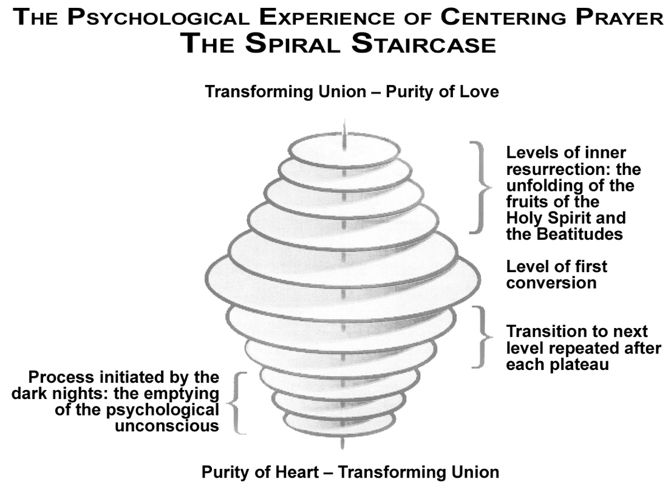
The level of first conversion would be this middle program. This is a spiral, a favourite image in our time. This is the downward movement [points to the levels below level of first conversion] that we saw expressed in the analogy of the Tell where step by step we experience an alternation in which we experience the purification of the unconscious. Sometimes I have suggested the term “the unloading of the unconscious”; because it is like getting rid of a load of junk that doesn’t belong there. And then after that, there is a period of transition from one level to another with a plateau in between of rest and refreshment in which one has time to integrate the new insight, whether psychological or spiritual into the whole of life — our relationship with God, ourselves and other people. This takes some time and you can’t rush this thing.
God has incredible patience and seems to wait for the right moment — sometimes a long time, in which you are most likely to consent to the insight that is to be communicated. Usually it is freedom from some compulsion or addictive process that has burdened you from the beginning. This is not punishment. It is an enormous gift or reward. It is the gift of ultimate health that deals with the very sources of illness and takes them away — over time.
Notice that at the same time you experience and accept one of those experiences of primitive emotions, or weakness or powerlessness, and it is evacuated, immediately this upper spiral is activated and one begins to have what might be called a moment of inner resurrection. In other words, the false self has been humiliated. The true Self has been exalted in the same process. Not necessarily right away because sometimes it takes weeks or months or a few years to complete a certain purification process. But in the other direction the experience of resurrection is certain — of one’s acceptance of what happens.
This begins to express this upper movement, the ontological unconscious begins to become conscious and the supernatural organism (true Self) begins to function. Faith, hope and love, the theological virtues, begin to grow and to be purified of the human motives involved in them. And as this occurs, the Fruits and Gifts of the Spirit emerge which are spontaneous ways of living that involve our consent but nonetheless are inspired by the Spirit within us who is replacing the false self now as our central mode of operation.
As we descend this level, this level goes up. They are both happening at once but this diagram does not quite express that. Imagine a spiral or a calyx. Something like the two strands of the DNA or the kundalini energy of Shiva and Shakti. One is going down and one is going up — at the same time. That would be the advantage if I could draw such a picture. Someone made a model of that and it is very effective. You can see the light going down and up at the same time.
So down is up and up is down. You can’t humble yourself without being exalted. And you can’t exalt yourself without being humbled. This diagram becomes a circle in which you arrive at the same place whichever spiral you are emphasising. You find purity of heart, the emptying of the unconscious junk of a lifetime and the transforming union, which is the full development of grace and the supernatural organism (true Self), the results of which move us towards the experience of Oneness in varying degrees.

