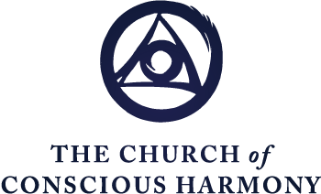

The Spiritual Journey
Formation in the Contemplative Christian Life
“The Human Condition: Evolutionary Model, Part 1”
Excerpted from
The Spiritual Journey Part 2

Fr. Thomas Keating

WHO ARE YOU?
We now come to the Human Condition. As you progress in the practice of Centering Prayer, one develops the need for a more conceptual background to understand what is happening. For a Christian, this conceptual background is basically the Scripture and the great doctrines of our faith: the Trinity, the Incarnation, grace. At the same time this great dogmatic teaching needs to be explained today in the context of contemporary science and human developments, especially psychology. One of the great benefits of contemporary psychology is precisely its precision as to what the human condition actually is. We’ll be basically asking ourselves “Who are you?” “Where are you?” It’s precisely in understanding the human condition, with the help of revelation, with the help of psychology, and the other contemporary sciences like sociology that cast a light on human values, we will be understanding exactly what contemplative prayer addresses.

As you know we all understand by the human condition today pretty much what tradition meant by the consequences of original sin. Now, original sin was never the personal fault of any of us. It’s attributed to the first parents as “The Fall.” And it’s an effort to explain human nature, and the most contemporary psychology tends to reinforce this for what it’s worth.

What I’m trying to hint is that the psychological evidence as it understands the pathology of human nature and its emotional illnesses more clearly through psychological advances is coming to almost identical conclusions as the doctrine, which is not only in the Christian scheme of things, but also appears in Hinduism and Buddhism and other religions as a kind of universal weakness that afflicts the human family from start to finish.

WHY STUDY MODELS OF THE HUMAN CONDITION?
What we’re going to do is to try to make use of the various models of the human condition that are now available as tools to discern the human condition. The hypothesis that I’m offering really in the spiritual journey is based on trying to bridge both the best development of psychology and religious experience and the traditional spiritual theology in the Christian system; and trying to enable us, by showing several distinct models, to get a kind of overall, a more comprehensive view so that we may then understand what the divine remedy is. In this perspective, the healing of the spiritual journey and especially of the contemplative dimension of the Gospel which accesses the higher levels of consciousness that are now available to the human being is to enable us to have a conviction and hence a motivation to submit to the divine therapy, the healing of the divine compassion and mercy, and to share that healing with other people who are similarly afflicted, so that not only ourselves may be redeemed but that we might contribute something to the great individual and social ills of our time.

[W]e hope to present a comprehensive view of the healing that the divine therapist proposes both for ourselves and for the social unit in which we live, and that unit in our contemporary consciousness is an extremely important development, perhaps never before realized in human history—is that our unit is the entire planet and everybody who lives on it and everything that exists in it. And so, as it moves, the healing is really a very down to earth kind of remedy. It enables us to belong to the human family as a whole without the barriers of race, ethnic group, religion, nation or any barrier, social or whatever—not that there’s not a certain value in each of these levels of human social development, but now they have to give way to a broader vision in which we see the human family as the supreme value of our social consciousness.

With that in mind, let’s take a look at the Evolutionary Model and, wouldn’t you have guessed it, here it is! [see chart on next page] Notice these are levels of developing consciousness. So here we owe a debt of gratitude to the anthropologists, archaeologists, historians, and other scientists in those fields for researching tirelessly the first flicker of the human consciousness as the evolutionary process evolves. Now as a Christian it’s important to realize that evolution is a perfectly normal way for God to function. It’s just as easy to evolve from the lowest forms of matter to the highest states of consciousness as it is for God to create everything brand new from stage to stage. So, without having to resolve your conscience on that matter, I’ll simply present this paradigm and you can do with it what you will.
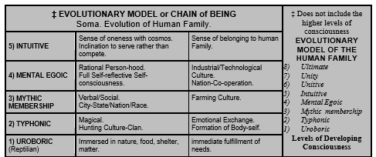

UROBORIC CONSCIOUSNESS
According to the anthropologists, then, the first glimmer of human consciousness, scarcely perceptible, probably began somewhere between five to six million years ago, when through the evolutionary process, or perhaps with a little nudge from God’s elbow, so to speak, or simply a nudge of the memory that matter seems to have of its Ultimate Source, even though it’s not conscious, there was a movement towards differentiating human consciousness from the material world and nature and the environment. And this the anthropologists usually call the Uroboric or the archaic consciousness, meaning the most primitive. In fact, the term Uroboric (meaning reptile) suggests the cycle, the endless cycle, or circular motion of events as it’s experienced by animals or human beings immersed in nature, such as the cycle of the seasons, of day and night, of desire and gratification, and of hunger and a good lunch.

At this level, this first movement of human consciousness is immersed in nature and its concern is primarily with food and shelter, the prompt fulfillment of its needs, and the concern to survive a day at a time. There’s no future for this level of consciousness. In fact, there is no self-consciousness. There is simply the carrying out of the movement of the instinctual needs of nature with an enormous amount of delight and gratification in the good things that this beautiful earth provides for each level of life; although that provision is not absolute—because in the mystery of creation, there is both wonderful things and the end of wonderful things. There is both life and death.
TYPHONIC CONSCIOUSNESS
So much for this Uroboric consciousness, and it lasted almost five million years. And then along came another little nudge of the creative movement of God, however you perceive this. And a Typhonic consciousness emerged, which is the emergence of a body self from nature. This is the first really significant distinction of self-identity. But, again, the self- consciousness is extremely limited, and the Typhon, which really means half-human, half-animal, is still immersed in nature and the instinctual concerns and anxieties of the Uroboric level, which is about food and drink and survival on a day to day basis. And this emerged about two hundred thousand BCE, according to the contemporary calculations. That consciousness lasted for almost two hundred thousand years also. Notice how slowly consciousness is moving, how long the periods of time in which this kind of half-animal, or immersion in animal instincts was part of the human experience. The Typhonic consciousness is characterized by several significant details: one is the inability to distinguish imagination from reality, the difficulty to distinguish the part from the whole. Thus, this is the beginning of tribal culture. There was no stratification of society in the Typhonic level (no kings and no wars). There was the hunt, and, no doubt, there was a certain possessiveness, but on such a moderate scale that the concern for day to day living and the necessity of the hunt in order to survive (it was a hunting kind of culture) put all the concerns that would later appear out of the imagination of this type of people.
MYTHIC MEMBERSHIP
Well, at some point in this long adaptation of Typhonic consciousness, in which it stabilized from the almost totally primitive immersion in nature of the Uroboric consciousness, language was invented—now maybe this was as much as fifty thousand BCE. In any case, it naturally accelerated the evolutionary process because of the enormous revolution that easy communication began to provide for ideas and possibilities. The Mythic Membership level of consciousness is identified by anthropologists as emerging somewhere from twelve to ten thousand BCE. This is the development of the city state, a period of socialization. And the great factor that seemed to bring that about was the discovery of farming. And farming over against hunting means you now have a surplus and can plan the future and some people can have the leisure to give their attention to religious ritual and exercises, to money matters, to planning for the future, to storing up resources, and enjoying the possibility of a future. All of these revolutionary developments in consciousness brought about a gradual stratification of society, with kings and nobles and patrons and clients and slaves, and, not the least, soldiers. Because once the development of possessions and the capacity to trade and to do business and to have land became values that at least the rich people could enjoy, then this obviously needed to be defended; hence the institution of the military came into being at this period and history now begins to be written and moves out of simple communication of grunts, or whatever our ancestors started off with, to a certain logical thinking. At the Mythic Membership level, the first dawn of reasoning is possible, but not abstract ideas, except in a very few pioneers of further development. But for the general, average level of consciousness, the logical thinking concerned in taking care of the instinctual needs in a way that was more efficient and effective than was possible in a hunting culture where everything depended largely on chance, or on the skill of harmonizing one’s plans with the natural cycles of the earth.
MENTAL EGOIC
Finally, about two to three thousand BCE, another remarkable revolution of consciousness occurred that is called the Mental Egoic. At the Mythic Membership, there’s the distinction of the body self from the environment. And now one’s identity comes not so much from nature as from the social unit, moving now into tribal interests but later into city state concerns and even into empire, a little bit later. The Mental Egoic level of consciousness characterizes the distinction of the mind as separate from the body; and this had great benefits, but also some disadvantages; the reason of the disadvantages being that this level of consciousness suggested the transcendence of reason over these more emotional levels of consciousness and hence there was the tendency to repress the seat of those emotions as well as the emotions themselves, which is the body and also the mythical symbols of the emotional values of earlier stages of human consciousness that came to be symbolized in the feminine values of caring, concern, nutrition, mothering, etc. And that’s easy to understand, I imagine, if you remember that in the Uroboric consciousness, that consciousness is embraced by the earth, or clings to the earth, and the soil, and nature, and the seasons as to a mother’s breast. This is all the reality that this level of consciousness knows. When the Mental Egoic begins to differentiate from that over-identification of earlier stages, this tendency to repress as a lesser value these earlier stages of consciousness.

INTUITIVE CONSCIOUSNESS
There is a further stage of consciousness—the Intuitive—which is a beginning to access the spiritual level of our being and it may be expressed by psychic gifts; but more importantly, it’s expressed by insights into the sense of belonging and unity with God and with the universe. In the view of this Evolutionary Model then, it proceeds beyond the stage in which is the common level of consciousness now into possibilities of growing even further. And it’s to those possibilities, of course, in which the spiritual journey, in all world religions, addresses itself with more or less force or urgency.

One reason we are looking at this Evolutionary Model is the fact that Ken Wilbur in his transpersonal psychology has united this Evolutionary Model with the developmental insights of modern psychology. And that insight might be put this way: that each of us from the time of conception until about fifteen or sixteen passes through each level of consciousness that the human family as a whole has been through or still lingers in, because not everybody has climbed these stages. We still find native peoples or primitive peoples in New Guinea and elsewhere whose basic culture is still hunting and whose value system is based on a Typhonic consciousness with its magical qualities, and at the same time its closeness to nature. Hence, in many ways, these people intuit and are closer to nature with its healing elements than we are, because in moving and differentiating our consciousness from the emotional levels that preceded them, we also repressed that part of our intuition.
THE VALUES AND THE LIMITATIONS OF EACH STAGE
This brings us to another observation of Ken Wilbur’s: and that is that these developments when they refer to the human family as a whole are not an uninterrupted development. As you might have suspected, if it took five million years to get from the Uroboric consciousness with the reptilian mythological symbol of the serpent eating its tail, symbolizing the consciousness of the recycling of everything in nature, including human life, I suppose, when they moved then into the Typhon, whose symbol is the totem pole, or the half-human, half-animal beast of mythology, these levels of consciousness have a true value. But the dis-value consists in the regressive tendencies that are present; since consciousness began immersed in nature, not all of the human family, or that group of humanity that is evolving, moves into the next level; and they may regress, or stabilize, or go back to lower levels, especially in a crisis of development or transition.

That means that this model is a kind of idealized model in which these levels of consciousness are ideal; but in actual fact, as each human unit or social unit moves from one to the other over time and whatever period they happen to be in the history of the world, they take with them both the values and the limitations of each stage and sometimes they become fixated in the limitations of the previous level of consciousness. And hence there is not a complete differentiation or a taking up of what was of value in the lower and re-expressing it in a more developed level of consciousness. So actually, the very words “lower” and “higher” are somewhat misleading because each one of these levels of consciousness has a value; it’s just that evolution seems to have a natural dynamic to move us into further expanded levels of consciousness, whether you want to call these higher or lower. Actually, they are higher potentialities, but in actual fact they may be lower, because one does not use them correctly and makes use of the further development of the brain to build bigger and better structures to maintain a Typhonic level of society.
RECAPITULATION OF OUR OWN EXPERIENCE
When we consider some of these as actually a recapitulation of our own experience, it alerts us to the fact that in our own conscious or subconscious are the very values that we can observe with the help of anthropologists as the various movements or stages of human consciousness as it moved from identification with nature to the ultimate self-differentiation of the Mental Egoic period. This differentiation has certain disadvantages. When we were immersed in nature as a race, or in our own individual development—and found in the womb or in mother’s arms and breasts the oceanic bliss that is allegedly characteristic of the first eighteen months of life; and seems to be really true. You often see the excitement of the infant in discovering something very prosaic, like your nose or something interesting, or pull your hair or your whiskers. And there’s a certain awe in the infant that is so delightful. And when it discovers something, it seems to open this ocean of bliss and it may giggle and sigh with pleasure; so that almost anything can turn on the child. This suggests that this, [pointing to Uroboric level on chart] especially the last five million years, was a hard level to relinquish for human beings when they were called by the evolutionary process or by the divine nudge to move a little more. It does seem as though evolution has a certain inevitability—even though everybody doesn’t make the integration; because when you notice the beauty of the child, and its pleasure in finding all its needs fulfilled by the promptitude of the mother’s care, then it tends to remain, or to be sucked back, so to speak, in that non-identity or no-self consciousness. It’s precisely after eight months or so when mother decides it’s time for baby to do a few things for itself, or she’s not quite so prompt, that this ambivalence as to its identification with the mother begins to arise.
REPRESSION OF THE GROUND OF BEING
Another transpersonal psychologist, Michael Washburn, has used this observation for a remarkable insight which he calls “original repression.” And in this explanation, he sees the child’s identification with its mother as, at the same time, identification with the ground of being, with the dynamic ground of being, which is supporting its life at every level, especially its polymorphous sensual delight throughout the body in all its experiences that it’s accumulating, at least the pleasant ones. And so, at the same time that the infant decides to set out on a new level of independence, on differentiating itself from mother, it begins to differentiate itself from its dynamic ground, the source of its being, and it begins to repress that energy, and this is a necessary development if the self is going to develop into an independent and strong ego. This observation, then, it seems to me, casts a further light on the evolutionary process and why there is such pain and ache in moving from one level of consciousness to another, and why it should not surprise us that in moving beyond the Mythic Membership or Mental Egoic level, we find this downward tug or this pain because of the former identification or the memory in our unconscious of the oceanic bliss or the age of innocence, which was a pre-rational level of consciousness, and hence did not have the sense of responsibility that we bring with us as we pass through our developmental stages from the womb to about fifteen years of age.
There is in us, then, both the values and the dis-values of each one of these levels. Ideally, the process would involve integrating all that was good at the previous level of consciousness into the new level which usually provides a higher synthesis and a greater range of awareness and growth. At the same time if there’s a fixation emotionally at one of these early levels, then the fixation is not integrated and then accompanies you through the rest of life. As one’s intelligence, perhaps spiritual life, physical nature grows, there remains the unintegrated value system from one of the previous levels of consciousness that is obviously not only inappropriate, but introduces a kind of civil war or pathology that is translated into the afflictive emotions of anxiety, turmoil, uncontrollable anger, lust, and the other afflictive emotions that we’ll be discussing later when we look at the Existential Model.
[See charts below]

THE MODEL OF CHRISTIAN GROWTH AND TRANSFORMATION BRINGS THE EVOLUTIONARY MODEL AND EXISTENTIAL MODEL TOGETHER
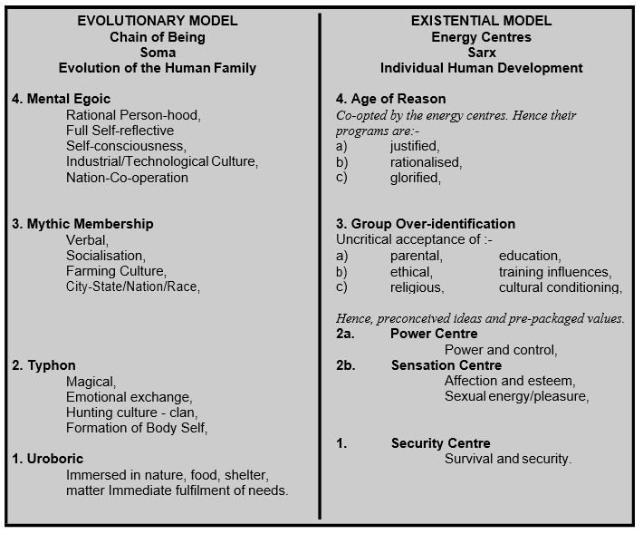

THE HUMAN CONDITION
A summary of the materials in the Spiritual Journey Part 2
