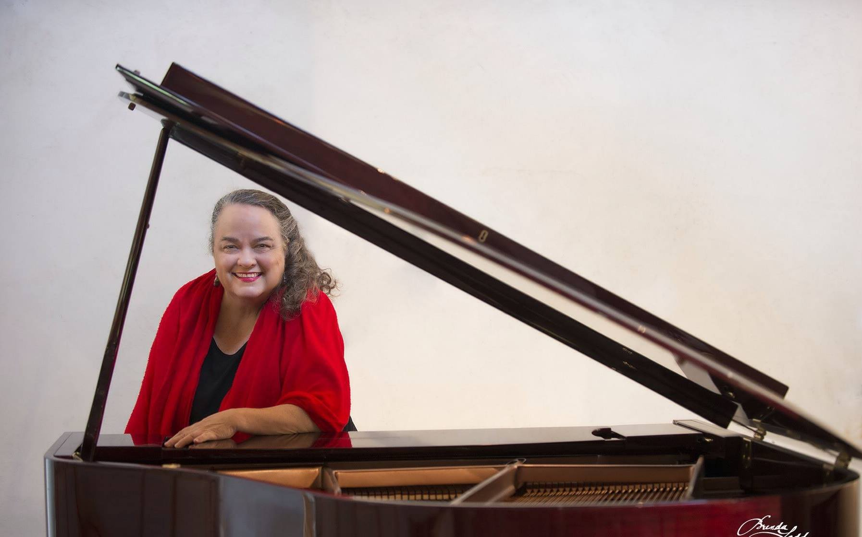

Susan Timmons Boulden, age 69, died unexpectedly in a motor vehicle collision on Thursday afternoon January 4, 2018 in her beloved hometown of Austin, Texas where she was born on May 25, 1948 to Cecil Foard ‘Red” Boulden Sr. and Effie “Lona” Mae Timmons Boulden. Her parents and her older brother Dr. Cecil Foard Boulden, Jr. preceded her in death.
Growing up in Austin, Susan graduated from McCallum High School and went on to graduate from the University of Texas with a BS in Nursing in 1970 and later with a Master in Social Work in 1994 from the same institution. In addition, she pursued graduate studies in piano at the University of Texas School of Music.
Susan was a woman of many talents who devoted her life to God and to others in service. She worked for nearly 28 years as the Music Director at the Church of Conscious Harmony where she played piano at Sunday services. She also led the congregation in chants she composed. Susan mastered the complex music of spiritual teacher and philosopher George Ivanovich Gurdjieff and delighted a loyal following at the church, performing a concert series of his music. She once described the classical music station KMFA as the “soundtrack of my life.” Few people who listened to her play will forget the depth, beauty, passion, and divine infusion in her music. She frequently played for audiences in retirement homes.
Besides her service to the church through her music, Susan worked for many years as a nurse bringing her cheer, compassion, skill, and extraordinary sense of humor to uplift dialysis patients, hospice patients and those with more medically complex problems than are served by traditional hospitals. Besides being a nurse, she was also trained as a social worker, adding to the skill set she brought to the people with whom she worked. She was inclusive in her embrace of spiritual disciplines. Besides her lifelong Christian practices she was a long-term devotee of Mata Amritanandamayi Devi, “the Hugging Saint” who stressed the importance of selfless service and love. Reflective of her ever-expanding heart and devotion to service, Susan spent her last Christmas on this earth serving meals to the homeless.
Her numerous friends will remember her for her disciplined unwillingness to entertain negative thoughts, her wisdom and passionate pursuit of spiritual evolution, her enveloping hugs, her quickness to stand up for what she believed and walk the talk including attending protests on issues dear to her heart, and her extraordinary sense of humor whereby she creatively transmuted the most mundane situation to one of hilarity, sometimes with just a single well-timed phrase. Reflecting her expansive desire to reach out include even more people in her orbit, a few months ago she presciently said, “I don’t have very much time left on this earth, and there are so many more people to meet.”
Susan is survived by her loving nephews Robert Foard Boulden of Fort Smith, Arkansas, Michael Rowe Boulden of Dallas, Texas, Patrick Timmons Boulden of Tulsa Oklahoma, Thomas Frazer Boulden of Memphis, Tennessee, Benjamin Boulden of Little Rock, Arkansas, and many many adoring great and great-great nieces and nephews “who will rise up and call her blessed.” Her many friends at the Church of Conscious Harmony and throughout Austin will cherish the memory of a woman who lived an inspiring life well-lived. We love you, Susan.
A Celebration of Life service will be held on Thursday 11 January 2018 at 1:00 PM at the Church of Conscious Harmony, 7406 Newhall Lane, Austin, TX 78746 (Phone: 512-347-9673). Website: http://consciousharmony.org

