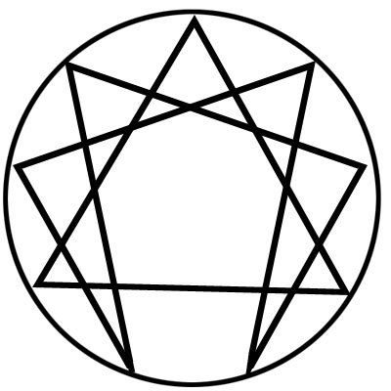

Gurdjieff Movements Class – Fall 2015

Gurdjieff Movements will be offered to congregants who meet the following prerequisites:

- Prior regular participation in CCH movements or participation in the Work of Inner Christianity classes for at least one year
- Have participated in a second line group for at least six months

The new class will be limited to 30, with 18 necessary to have the class. Consistent class attendance will be required to support the work of the group as a whole as well as each participant’s inner Work.

Class will meet in the Fellowship Hall at the following times:
- First Saturday of each month, from 10:00-11:30am (Oct 3, Nov 7, Dec 5)
- Thursdays from 6-7pm on Sep 17 & 24; Oct 1, 15, 22 & 29; Nov 5 &19; Dec 3

Movements can be physically demanding for some people. Signature on a formal ‘waiver/release’ document will be needed from each participant. They will be distributed and signed at the first class meeting on September 17th. Specific attire is necessary for participation and will be discussed on September 17th as well.

To register, please email officemgr@consciousharmony.org or call the Church office at 512-347-9673, or visit the office in person. Registration will be open until August 31, 2015.

Participation in Movements qualifies as a Work Group study for the purpose of the Rule of Life, for those who have chosen to participate in this level of study and devotion.

Movements instructors are Don Hale, Bev McCune, Rhonda Raymond and Jack Stamps. Musicians are Susan Boulden and Michael Marin.

Jack Stamps is the contact person for Movements at 512-658-0058.

